Project Integration
Management

1. Introduction to Project Integration Management

1.1 What is Project Integration Management?
Project Integration Management is the process of coordinating all parts of a project so they work together smoothly. Think of it as the glue that holds every other knowledge area together.
A project manager who masters integration management ensures that every piece of the project — scope, time, cost, quality, risk — is planned, executed, and controlled in a connected and consistent way.

Key Points
- It coordinates ALL other project knowledge areas throughout the entire project life cycle.
- It is NOT the same as software integration (i.e., connecting software systems).
- The project manager is the person responsible for integration management.
- Good integration management is the key to overall project success.

The Integration Management Process Flow
The diagram below shows how integration management flows from the very start of a project to its closing, producing key outputs at each stage.

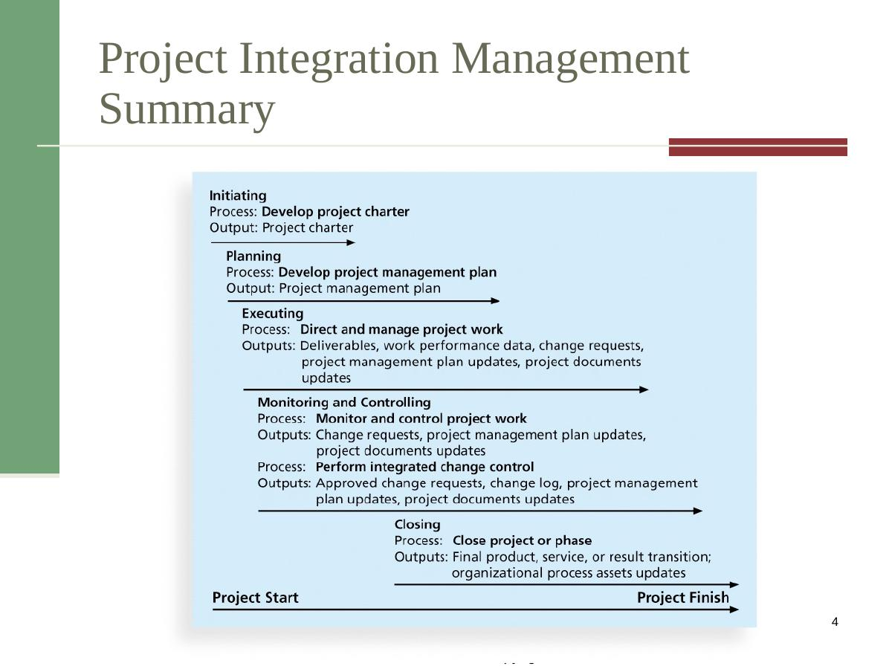
Figure 1: Project Integration Management – Full Process Flow (Initiating → Planning → Executing → Monitoring & Controlling → Closing)
This flow diagram is important because it shows how each process group connects. Notice that the arrow goes from Project Start to Project Finish, and that Monitoring & Controlling covers the longest period — change control is an ongoing activity.

1.2 The Five Integration Management Processes
There are five main processes in project integration management. Each process belongs to a process group and produces a specific output.

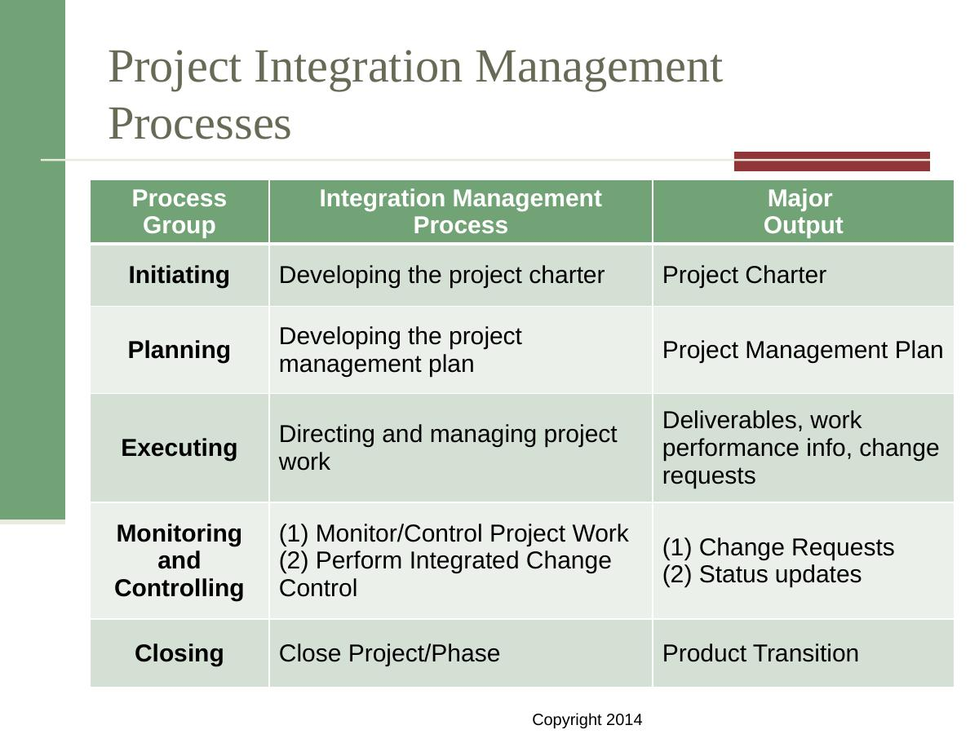
Figure 2: Project Integration Management Processes Table – Process Group, Process, and Major Output

Here is a summary of all five processes:

Process Group | Integration Process | Major Output
Initiating | Develop the Project Charter | Project Charter (signed)
Planning | Develop the Project Management Plan | Project Management Plan
Executing | Direct and Manage Project Work | Deliverables, Work Performance Info, Change Requests
Monitoring & Controlling | Monitor / Control Project Work | Change Requests, Status Updates
Monitoring & Controlling | Perform Integrated Change Control | Approved/Rejected Changes, Change Log
Closing | Close Project or Phase | Final Product Transition, Process Asset Updates

Exam Note
- Memorize this table — examiners frequently ask which process belongs to which process group.
- The KEY output of Initiating is the signed Project Charter.
- Monitoring & Controlling has TWO integration processes — monitor/control work AND integrated change control.
- Common question: 'Which process group issues the project charter?' Answer: Initiating (by senior management, not the PM).

2. Strategic Planning and Project Selection

2.1 Strategic Planning
Strategic planning means an organization looks at its long-term goals and decides what it needs to do to achieve them. This includes predicting future trends and deciding what new products or services to create.

SWOT Analysis
A common tool used during strategic planning is SWOT Analysis. SWOT stands for:
- Strengths – things the organization does well internally
- Weaknesses – areas where the organization is lacking
- Opportunities – external trends that the organization can use to its advantage
- Threats – external challenges or risks that could harm the organization

After a SWOT analysis, an organization identifies which IT projects best support its strategic goals.

2.2 Information Technology Planning Process
IT planning follows a four-stage pyramid model. The top of the pyramid is most strategic; the bottom is most operational.

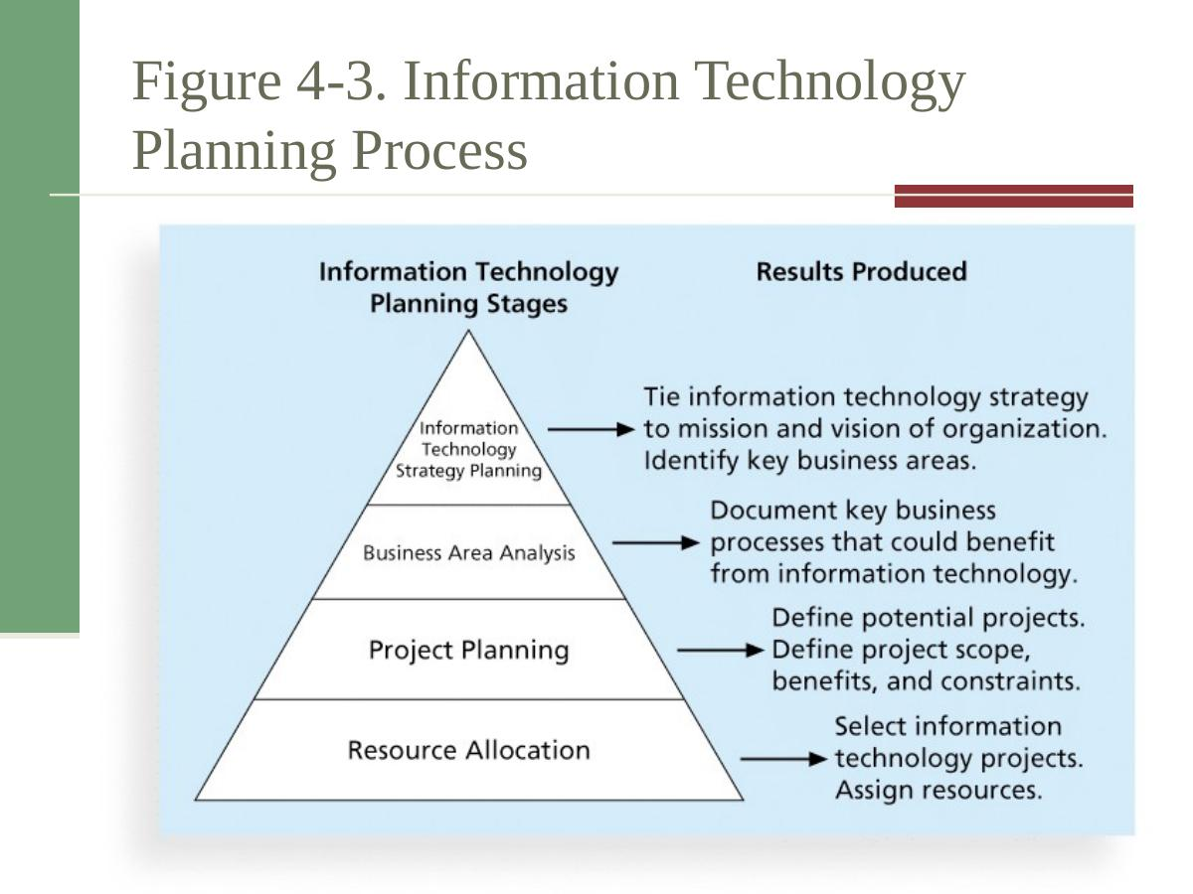
Figure 3: IT Planning Process Pyramid – Four stages from IT Strategy Planning down to Resource Allocation

Stage | What Happens
1. IT Strategy Planning | Connect IT strategy to the organization's mission and vision. Identify key business areas.
2. Business Area Analysis | Document the key business processes that could benefit from IT.
3. Project Planning | Define potential projects. Define scope, benefits, and constraints for each.
4. Resource Allocation | Select the IT projects to pursue. Assign people and budget to them.

2.3 Why Some Companies Consistently Succeed in New Product Development
Research shows only 1 in 7 product ideas reaches the market. Companies like Procter & Gamble, HP, and Sony succeed consistently because they use a disciplined, systematic approach. Four key forces drive their success:
- A product innovation and technology strategy for the business.
- Strong portfolio management — focusing resources on the right projects.
- An effective, flexible idea-to-launch process.
- The right culture: cross-functional teams, senior management commitment, and openness to innovation.

2.4 Methods for Selecting Projects
Organizations always have more project ideas than available time and resources. Several methods help choose which projects to pursue:

Method | Description
Feasibility Study | Asks: 'Can this project actually be done?' Evaluates technical and business feasibility before committing resources.
Benefits Contributions | Evaluates how much the project contributes to organizational goals. Difficult to quantify but important.
Economic / Financial Models | Uses NPV, ROI, or Payback analysis to measure financial value (see Section 2.5).
Scoring Models | Uses a weighted criteria list to score and rank competing projects objectively.

Method A: Focusing on Broad Organizational Needs
Many IT projects are hard to justify with numbers, but everyone agrees they provide great value. Three criteria are used to evaluate these projects:
- Necessity – Is the project absolutely needed?
- Funding – Is the money available to do it?
- Will – Is there organizational will and support to complete it?

Method B: Categorizing IT Projects
Projects can be placed into one of three categories:
- Problem – The project addresses an existing problem (e.g., a system that keeps crashing).
- Opportunity – The project takes advantage of a business opportunity (e.g., entering a new market).
- Directive – The project is required by law, regulation, or management directive.

2.5 Financial Analysis Methods
Three financial tools are used to evaluate the economic value of a proposed project. All three are frequently tested in exams.

Method 1: Net Present Value (NPV) Analysis
NPV is the most important financial method in IT project management. It calculates the total financial gain or loss from a project by converting all future cash flows into today's money (present value).

Core idea: A dollar today is worth more than a dollar in the future, because money can earn interest. NPV adjusts for this.

NPV Formula

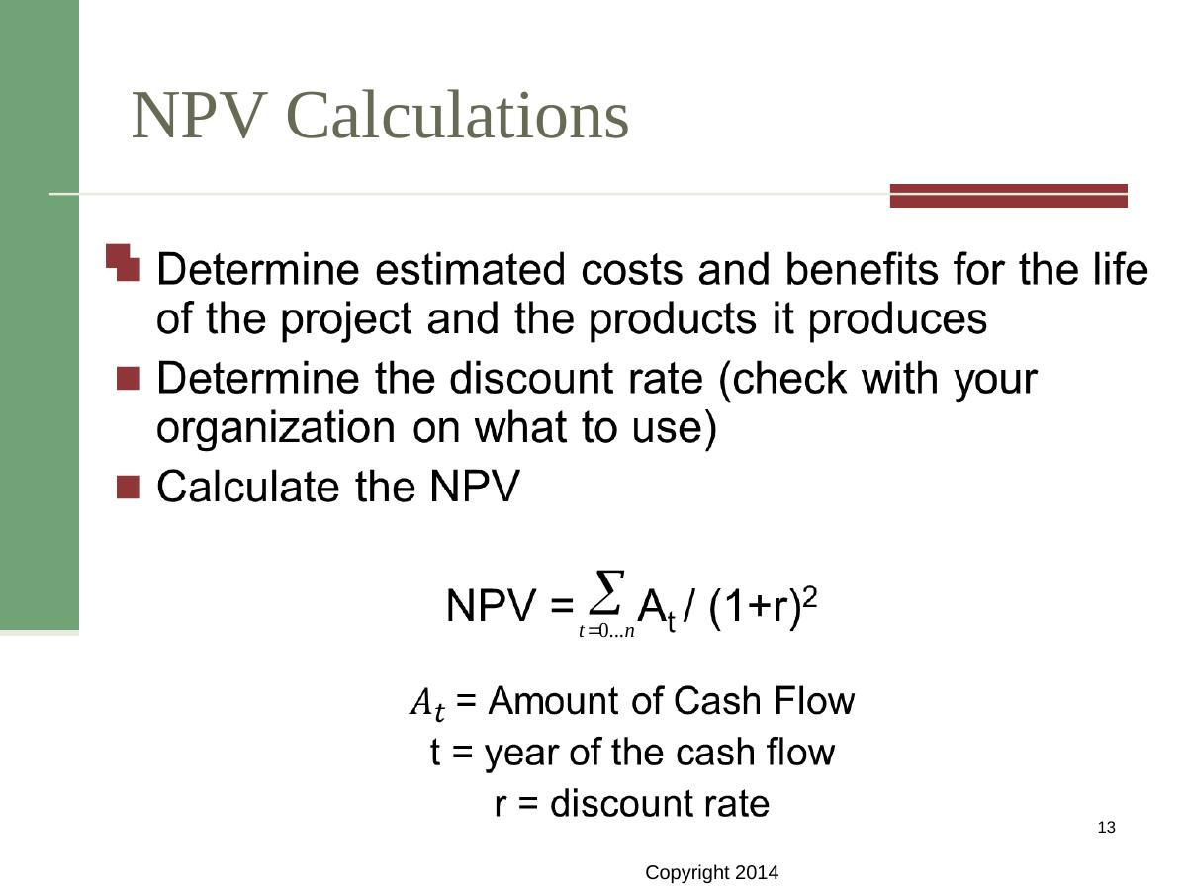
Figure 4: NPV Formula – NPV = Sum of (Cash Flow at time t) / (1 + r)^t where r = discount rate

Formula breakdown:
- A_t = Amount of cash flow (positive = benefit, negative = cost) in year t
- t = the year number (0, 1, 2, 3, ...)
- r = the discount rate (provided by your organization, e.g. 8%)
Calculation steps:
- Estimate all costs and benefits for the life of the project.
- Find the discount rate from your organization.
- For each year, calculate the discount factor = 1 / (1 + r)^t
- Multiply each year's cost and benefit by its discount factor to get discounted values.
- Sum all discounted benefits minus all discounted costs = NPV.

Decision rule: If NPV > 0, the project adds value and should be selected. If NPV < 0, avoid the project.

Worked Example: JWD Consulting

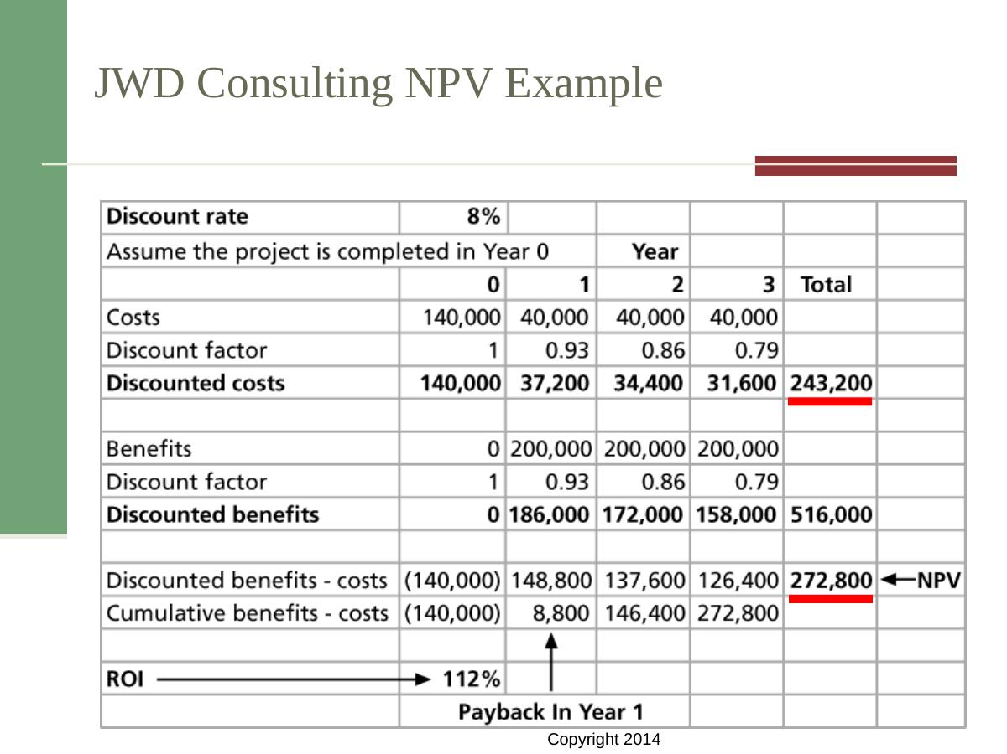
Figure 5: JWD Consulting NPV Calculation – Discount Rate 8%, Project completed in Year 0

Given data for JWD Consulting:
- Discount Rate: 8%
- Costs: Year 0 = $140,000; Years 1–3 = $40,000 per year
- Benefits: Year 0 = $0; Years 1–3 = $200,000 per year

Discount factors: Year 0 = 1.00 | Year 1 = 0.93 | Year 2 = 0.86 | Year 3 = 0.79
Total discounted costs = $140,000 + $37,200 + $34,400 + $31,600 = $243,200
Total discounted benefits = $0 + $186,000 + $172,000 + $158,000 = $516,000
NPV = $516,000 – $243,200 = $272,800 ← Positive, so this is a good project!
Payback occurs in Year 1 (cumulative benefits exceed cumulative costs).

Method 2: Return on Investment (ROI)
ROI shows what percentage return the organization gets on every dollar invested.

Formula: ROI = (Total Discounted Benefits – Total Discounted Costs) / Total Discounted Costs

Using JWD Consulting numbers:
ROI = ($516,000 – $243,200) / $243,200 = $272,800 / $243,200 ≈ 1.12 = 112%
This means for every $1 spent, the organization gets back $2.12 (original $1 plus $1.12 profit). A positive ROI means the project is profitable.

Decision rule: Higher ROI is better. Projects with negative ROI destroy value and should normally be avoided.

Method 3: Payback Analysis
The payback period is how long it takes to get back the money invested in a project from the project's net cash inflows.

It is the simplest financial method — you just track when cumulative benefits exceed cumulative costs.
- In the JWD example, cumulative net = –$140,000 in Year 0, then +$8,800 in Year 1. Payback happens in Year 1.
- Projects with shorter payback periods carry less financial risk.
- Limitation: Payback ignores the time value of money (unlike NPV).

Financial Methods – Exam Note
- Know all three formulas: NPV, ROI, Payback period.
- ROI formula: (Discounted Benefits – Discounted Costs) / Discounted Costs.
- NPV > 0 means select the project; NPV < 0 means reject.
- Payback analysis: identify the year when cumulative net cash flow turns positive.
- In the JWD example: NPV = $272,800, ROI = 112%, Payback in Year 1.
- Discount factor formula: 1 / (1 + r)^t.

2.6 Weighted Scoring Model
A weighted scoring model is a structured tool for comparing multiple projects across many criteria. It gives a score to each project and helps decision-makers choose fairly.

How to Build a Weighted Scoring Model – Step by Step
- Identify the criteria that matter for project selection.
- Assign a weight (percentage) to each criterion so all weights add up to 100%.
- Score each project on each criterion (e.g., on a scale of 0–10).
- Multiply each score by its weight to get a weighted score.
- Add all weighted scores for each project to get a total weighted score.
- Select the project with the highest total score.

Sample Criteria and Weights
Criterion | Weight
Supports key business objectives | 25%
Positive NPV | 30%
One year or less to implement | 20%
Strong internal sponsor | 15%
Strong customer support | 10%
TOTAL | 100%

Sample Project Comparison
Factor | Project 1 | Project 2 | Project 3
Timeline | ~1 year (estimates may change) | 6 months (low risk) | 18 months (long)
Sponsor | Many executives support it | Manager-level only | CIO + executive support
NPV | Positive (if on budget) | Negative | Positive (4-yr payback)
Strategic Fit | Technology upgrade goal | Internal tracking site | Customer service strategy
Likely Score | High | Low (negative NPV) | High (but long timeline)

Project 3 likely scores highest because it has executive support, strategic alignment, and positive NPV — despite a longer timeline.

2.7 Balanced Scorecard
A balanced scorecard converts an organization's key value drivers into measurable metrics. It looks at performance from four angles:
- Financial performance – Are we financially healthy?
- Customer service – Are customers satisfied?
- Internal processes / Operational efficiency – Are our processes working well?
- Innovation / Learning & growth – Are we improving and innovating?
The balanced scorecard helps organizations ensure their IT projects align with overall business strategy, not just financial performance.

2.8 Additional Selection Methods
- Opportunity Costs – The value of the next best alternative you give up when choosing a project.
- Six Sigma – A data-driven methodology that selects projects based on their ability to reduce defects and improve quality.

3. Initiating: Developing the Project Charter

3.1 What is a Project Charter?
A project charter is an official document that formally announces a project exists. It gives the project manager the authority to use organizational resources and begin work.

The project charter is the key output of the Initiating process group. Without a signed charter, a project is not officially authorized.

Key Points about the Project Charter
- It formally recognizes the existence of the project.
- It provides direction on the project's objectives and management approach.
- It is signed by senior management (sponsor), not the project manager.
- It gives the project manager the authority to use resources.

Typical Contents of a Project Charter
Section | What It Contains
Project Title | Short, clear name for the project
Project Start/End Date | Planned dates for beginning and completion
Project Manager | Name and contact of the PM assigned
Budget Information | Estimated budget or financial range
Project Objectives | What the project will achieve (specific outcomes)
Approach / Methodology | How the project will be conducted
Roles and Responsibilities | Who does what on the project team
Sign-off | Signatures of key stakeholders (especially sponsor)

Inputs for Developing the Project Charter
The inputs that feed into developing a charter include:
- Project statement of work (SOW) – a description of the products or services the project will deliver
- Business case – justification for the project
- Agreements – contracts or memoranda of understanding
- Enterprise environmental factors – company culture, existing systems, regulations
- Organizational process assets – templates, historical data, lessons learned

Exam Note – Project Charter
- WHO issues the charter? Senior management (performing organization), NOT the project manager.
- The charter is the result of the Initiating process group.
- Without a signed charter, a project has no formal authorization.
- Common exam question: 'What is the key output of Initiating?' Answer: Project Charter.
- CAPM question: 'What document is the result of project initiation?' Answer: Project Charter.

4. Planning: Developing the Project Management Plan

4.1 What is the Project Management Plan?
The project management plan (PMP) is the master planning document for the entire project. It coordinates all other planning documents and guides how the project will be executed and controlled.
Think of it as the project's instruction manual. Every team member, manager, and stakeholder refers to it throughout the project.

Common Elements of a Project Management Plan
- Introduction / Overview – What the project is about
- Project Organization – How the team is structured
- Management Processes – How decisions will be made, risks managed, issues resolved
- Technical Processes – Technical standards and approaches to be used
- Work to be Done – Description of tasks and deliverables
- Schedule – Timeline and milestones
- Budget – Cost estimates and financial plan

Software Project Management Plan (SPMP)
For software projects, the plan is often called a Software Project Management Plan (SPMP). It contains sections covering: overview, project organization, managerial process plans, technical process plans, and supporting process plans.

Tip: Why Planning Matters
- Research shows that winning project managers clearly define what, who, when, and how.
- Using standard templates (e.g., scheduling templates) saves time and reduces uncertainty.
- Weak project managers start from a blank page every time — this wastes time and increases errors.

5. Executing: Directing and Managing Project Work

5.1 What is the Executing Process?
The executing process involves managing and performing the actual work of the project as described in the project management plan. The project manager directs the team, resolves problems, and ensures deliverables are produced.

- Planning and execution are tightly connected — as work proceeds, plans may need updating.
- The project manager must be a strong leader, not just a planner.

5.2 Leadership and Culture
Project managers must lead by example. They must show the team that following the project plan is important. A supportive culture means team members feel safe to raise issues, take initiative, and collaborate openly.

5.3 Technical and Business Knowledge
It helps greatly if IT project managers have some prior technical experience. This gives them credibility with the team and helps them understand risks and issues better. However, their primary role is management, not hands-on technical work.

- Small projects: the PM may do some technical work.
- Large projects: the PM focuses entirely on coordination, communication, and decision-making.

5.4 Tools and Techniques for Project Execution
Tool / Technique | Description
Expert Judgment | Use advice from experienced team members, consultants, or stakeholders.
Meetings | Regular team meetings to review progress, resolve issues, and communicate.
Project Management Info Systems | Software tools (e.g., MS Project) to track tasks, schedule, budget, and resources.

6. Monitoring and Controlling Project Work

6.1 Why Monitoring Matters
Changes are inevitable on every project. Monitoring and controlling means watching the project, measuring performance, and taking corrective action when needed.
- Collect, measure, and distribute performance information.
- Compare actual progress to the baseline plan.
- Identify variances and take corrective action.

What is a Baseline?
A baseline is the approved project management plan plus any approved changes. It is the yardstick against which actual performance is measured. You cannot measure deviation without a baseline.

6.2 Performing Integrated Change Control
Integrated change control is the process of reviewing and managing all changes requested during the project. Its three main objectives are:
- Influence the factors that cause changes — minimize unnecessary change.
- Detect that a change has occurred — recognize deviations from the plan.
- Manage actual changes when they occur — evaluate, approve, or reject changes formally.

Former vs. Modern View of Change Control
Aspect | Former View (Problem) | Modern View (Solution)
Attitude to change | Resist change — stick to the original plan | Accept that change is inevitable; plan for it
Process | Informal, ad-hoc changes made without documentation | Formal change control system with documented steps
Decision-making | Anyone can make changes informally | Only authorized people approve changes via a CCB
Documentation | Little or no record-keeping of changes | All changes are logged and tracked

6.3 Change Control System
A change control system is a formal, documented process that describes when and how official project documents may be changed. It specifies who is authorized to make changes and the exact steps to follow.

6.4 Change Control Board (CCB)
A Change Control Board (CCB) is a formal group of people responsible for approving or rejecting project changes. The CCB:
- Reviews all formal change requests.
- Provides guidelines for preparing change requests.
- Evaluates the impact of each requested change on scope, time, cost, and quality.
- Approves, rejects, or defers changes and communicates decisions.

6.5 Configuration Management
Configuration management ensures that the project's products (deliverables) are accurately described and that changes to them are tracked and controlled.
- It identifies and controls the functional and physical characteristics of products.
- It maintains documentation so everyone knows exactly what version of a product exists at any time.
- It prevents unauthorized changes to project deliverables.

6.6 Suggestions for Performing Integrated Change Control

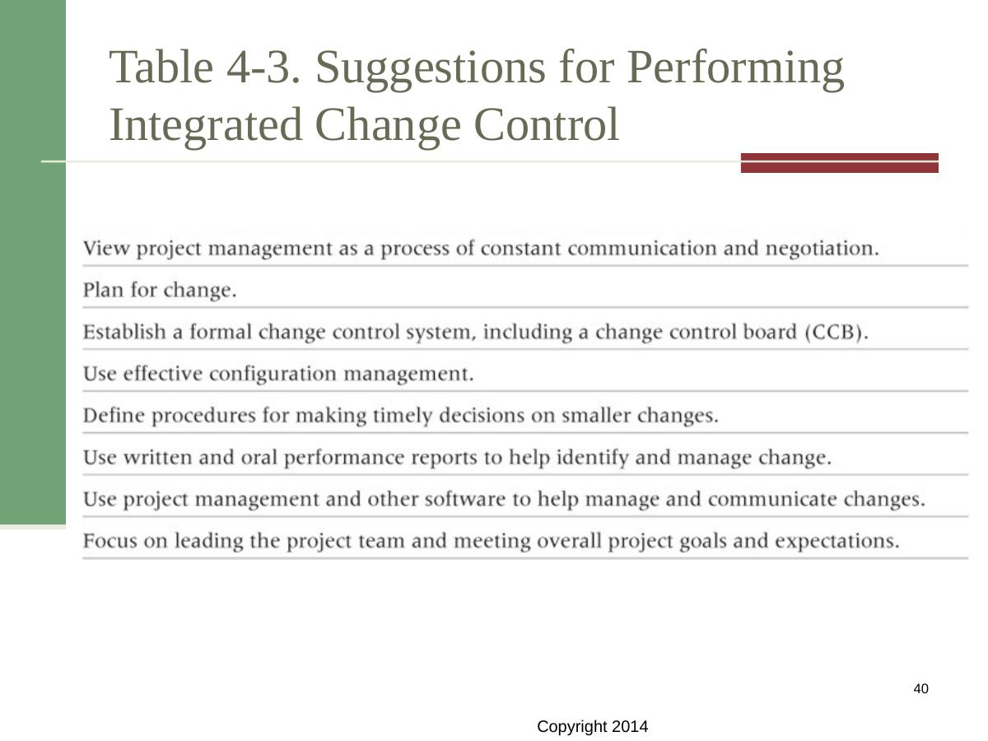
Table 4-3: Key suggestions for performing integrated change control effectively

The eight key suggestions from the textbook are:
- View project management as a process of constant communication and negotiation.
- Plan for change — assume changes will happen and build in flexibility.
- Establish a formal change control system, including a Change Control Board (CCB).
- Use effective configuration management.
- Define procedures for making timely decisions on smaller changes.
- Use written and oral performance reports to help identify and manage change.
- Use project management software to communicate and manage changes.
- Focus on leading the project team toward overall project goals and expectations.

Exam Note – Change Control
- Integrated change control runs 'from initiating through closing' — not just during execution.
- Who authorizes project closure? The project sponsor (not the project manager).
- A change control board (CCB) approves or rejects changes — it does not implement them.
- Configuration management tracks product versions and descriptions.
- Common exam question: 'Integrated change control manages changes at which stage?' Answer: From initiating through closing.

7. Closing the Project or Phase

7.1 What Happens at Closing?
Project closing means finalizing all activities and formally ending the project or a phase of the project. All open items are resolved and all work is handed over.

Main Outputs of Project Closing
- Final product, service, or result transition – The completed deliverable is handed to the customer or operational team.
- Organizational process asset updates – Lessons learned, templates, and historical data are stored for future projects.

Steps in Closing a Project
- Confirm all deliverables are complete and accepted by the customer.
- Finalize all procurement contracts and close supplier relationships.
- Release project team members back to their functional departments.
- Archive all project documents and records.
- Conduct a lessons-learned review to capture what went well and what to improve.
- Get formal sign-off from the sponsor or customer.

Exam Note – Closing
- Who can authorize closure? The Project Sponsor (per CAPM questions in the slides).
- Organizational process assets include lessons learned, templates, and historical records.
- Lessons learned are critical — they improve future project performance.

8. Using Software for Project Integration Management

8.1 Types of Software
Several types of software can support integration management:
- Project management software (e.g., Microsoft Project, Basecamp, Jira) – pulls together schedules, budgets, resource allocations, and project status in one place.
- Business Service Management (BSM) tools – track the execution of business process flows and help monitor overall project health.

These tools help project managers see detailed and summarized information in real time, communicate with stakeholders, and manage changes efficiently.

9. Chapter Summary and Quick Revision Notes

9.1 Summary of Key Concepts
Project Integration Management coordinates all other knowledge areas throughout the entire project life cycle. Here is a quick summary of the six main processes:

# | Process | Group | Key Output
1 | Develop Project Charter | Initiating | Signed Project Charter
2 | Develop Project Management Plan | Planning | Project Management Plan
3 | Direct and Manage Project Work | Executing | Deliverables, Work Performance Info
4 | Monitor and Control Project Work | Monitoring & Controlling | Change Requests, Status Updates
5 | Perform Integrated Change Control | Monitoring & Controlling | Approved Changes, Change Log
6 | Close Project or Phase | Closing | Final Product Transition, Lessons Learned

9.2 Key Definitions to Memorize
- Project Integration Management: Coordinating all project knowledge areas throughout the life cycle.
- Project Charter: Official document that formally authorizes a project.
- Project Management Plan: Master document guiding execution and control.
- Baseline: Approved project plan plus approved changes; used for performance measurement.
- Change Control System: Formal process for managing changes to project documents.
- Change Control Board (CCB): Formal group that approves or rejects change requests.
- Configuration Management: Ensures product descriptions are accurate and controlled.
- NPV: Net monetary gain or loss from a project, discounted to present value.
- ROI: (Discounted Benefits – Discounted Costs) / Discounted Costs, expressed as a percentage.
- Payback Period: Time needed to recoup the total investment from net cash inflows.
- Weighted Scoring Model: Tool that scores projects against weighted criteria.
- Balanced Scorecard: Framework that measures performance across finance, customers, processes, and innovation.
- SWOT Analysis: Evaluates Strengths, Weaknesses, Opportunities, and Threats.

9.3 Key Formulas
Formula | Expression | Variables
NPV | NPV = Sum(A_t / (1+r)^t) | A_t = cash flow in year t; r = discount rate; t = year
ROI | (Total Disc. Benefits – Total Disc. Costs) / Total Disc. Costs | Expressed as a decimal or %
Discount Factor | 1 / (1 + r)^t | r = discount rate; t = year number
Payback Period | Year when cumulative net cash flow becomes positive | Track year by year

10. One-Page Exam Revision Sheet
Use this section in the final 10 minutes before your exam. It covers every frequently-tested point in Chapter 4.

Critical Definitions
Term | One-Line Definition
Project Integration Management | Coordinating ALL knowledge areas throughout the project life cycle.
Project Charter | Official document that formally authorizes the project (signed by senior mgmt).
Project Management Plan | Master planning document coordinating all other plans.
Baseline | Approved plan + approved changes = performance measurement yardstick.
Change Control System | Formal documented process for making changes to project documents.
CCB | Change Control Board — approves or rejects change requests.
Configuration Management | Controls product descriptions and version accuracy.
NPV | Total financial value of a project, discounted to present value.
ROI | (Benefits – Costs) / Costs — measures profitability as a percentage.
Payback Period | Time to recoup the original investment from net cash inflows.
Weighted Scoring Model | Tool that scores projects on weighted criteria to select the best option.
Balanced Scorecard | Converts value drivers (finance, customers, processes, innovation) into metrics.
SWOT Analysis | Strategic tool: Strengths, Weaknesses, Opportunities, Threats.

Frequently Tested Theory Questions
- Q: What is the key output of the Initiating process group? A: Project Charter (signed).
- Q: Who issues the project charter? A: Senior management / performing organization (NOT the PM).
- Q: When does integrated change control apply? A: From initiating through closing (entire life cycle).
- Q: Who authorizes project closure? A: The Project Sponsor.
- Q: What does NPV > 0 mean? A: The project adds value — select it.
- Q: What are the three financial analysis methods? A: NPV, ROI, Payback Analysis.
- Q: What is a baseline? A: Approved project plan plus approved changes.
- Q: What does a CCB do? A: Approves or rejects change requests.
- Q: How many integration management processes are there? A: Six.
- Q: Which process group has TWO integration processes? A: Monitoring & Controlling.

Key Formulas for Exam
- NPV = Sum of [A_t / (1+r)^t] for t = 0 to n
- ROI = (Total Discounted Benefits – Total Discounted Costs) / Total Discounted Costs
- Discount Factor for year t = 1 / (1 + r)^t
- Payback = year when cumulative net cash flow first becomes positive

CAPM Practice Questions (from Slides)
Question | Answer
Which group issues the project charter? | Performing organization's higher management (Option A)
What document results from project initiation? | Project Charter (Option B)
Integrated change control is used at which stage? | From initiating through closing (Option A)
Which stakeholder can authorize project closure? | Project Sponsor (Option C)

Important Comparisons
Former View of Change Control | Modern View of Change Control
Resist and ignore change | Plan for change and manage it proactively
Informal, undocumented changes | Formal change control system with CCB
Anyone can make changes informally | Only authorized people approve changes
No version control | Configuration management maintains accuracy

NPV | ROI | Payback
Absolute dollar value of project | Percentage return on investment | Time to recover investment
Considers time value of money | Considers time value of money | Does NOT consider time value of money
Best for go/no-go decisions | Best for comparing profitability | Best for measuring financial risk
Positive = select; Negative = reject | Higher % = better | Shorter period = less risk

Final Exam Reminders
- Integration Management coordinates ALL other knowledge areas — it is the 'glue' of project management.
- The Project Charter is SIGNED by senior management, not the PM.
- Baseline = approved plan + approved changes. You cannot measure progress without it.
- Changes can happen anytime — that is why integrated change control spans the ENTIRE project.
- NPV > 0 = good project. ROI formula: (Benefits – Costs) / Costs. JWD example: NPV=$272,800, ROI=112%.
- The six processes in order: Charter → Management Plan → Direct Work → Monitor Work → Change Control → Close.

